INFORMATICA SERVER– 9.0.1 INSTALLATION
On ORACLE LINUX
Document Version: | 1.0
Publication Date: | 26-MARCH-2013
Owner: | ANIL KUMAR BORRU
Mail ID: | Anil.borru@gmail.com

Proprietary and Confidentiality notice This document contains confidential information that is the property of Anil kumar Reproduction, utilization or disclosure of the proprietary portion of this document is prohibited.

Document Change Log:
Version | Date | Prepared By | Description of Change
1.0 | 26-03-2013 | ANIL KUMAR BORRU | CompleteDocumentation

Table of Contents
1 Introduction 3
1.1 Background 3
1.2 Purpose of Document 3
2 Environment Details 3
2.1 Linux System Login Details 3
2.2 Informatica Database Domain Details 3
2.3 Informatica Administrator Details 3
3 Prerequisites for Informatica Server Installation 4
4 Informatica Server Installation 5
5 Testing on Informatica Installation 9

Introduction

Background

Purpose of Document

Environment Details

Linux System Login Details
Login User Name | obiee
Password | Password Provided by ETL Team
Root Password | Password Provided by ETL Team
Domain Name
IP Address
Host Name | obiee

Informatica Database Domain Details

Informatica Domain Name | Domain_obiee.7stl.com
Informatica Domain User Name | Infa_domain
Informatica Domain User Password | Password Provided by ETL Team
Oracle Service Name
Database address & Port Number

Informatica Administrator Details

Informatica Administrator User Name | Administrator
Informatica Administrator Password | Password Provided by ETL Team

Prerequisites for Informatica Server Installation
- Firewall should be disabled.
- Open oracle port from oracle server to Informatica Server.
- Open Informatica port from Informatica server to Informatica Client machine
- Create two oracle users with DBA privileges:
Ex: 1.username: infa_domain
password: info123
2.username: infa_etl
password: info123
- Install any Browser (Internet explorer/Mozilla Firefox) in Informatica server.

Informatica ServerInstallation

Step-1:

Create Directory and run Install.sh file

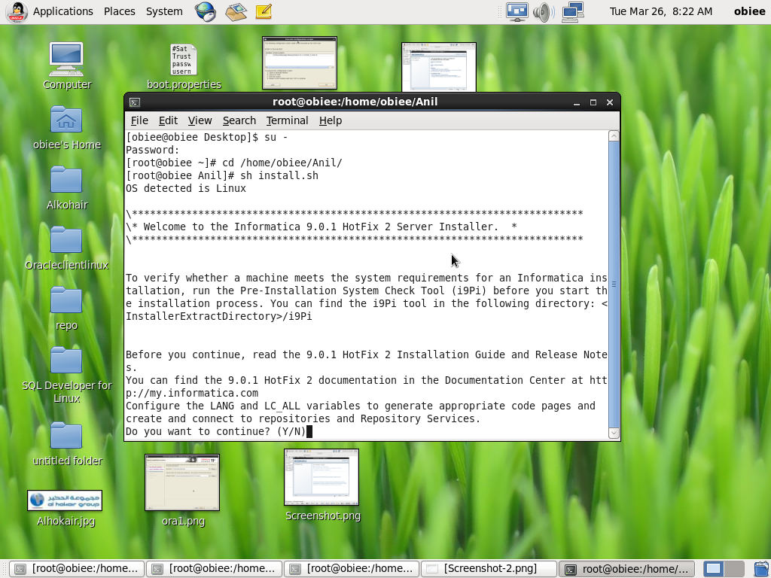

Step-2:

Select “Install Informatica 9.0.1 with Hotfix 2” and Click “Next”

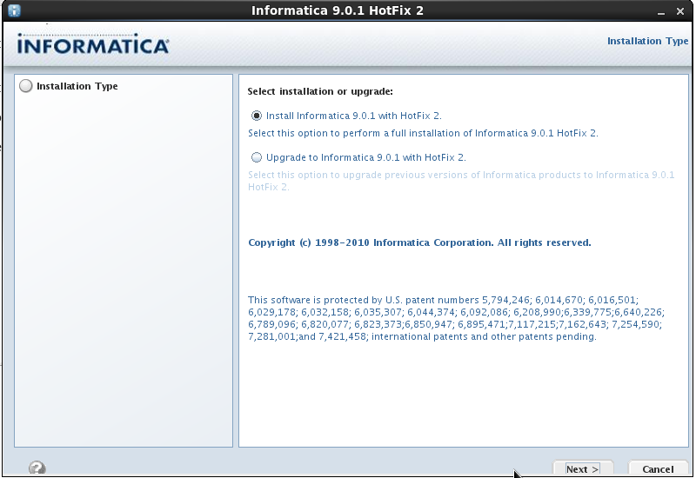

Step-3:

Select License file from directory and Select Installation Path then Click “Next”

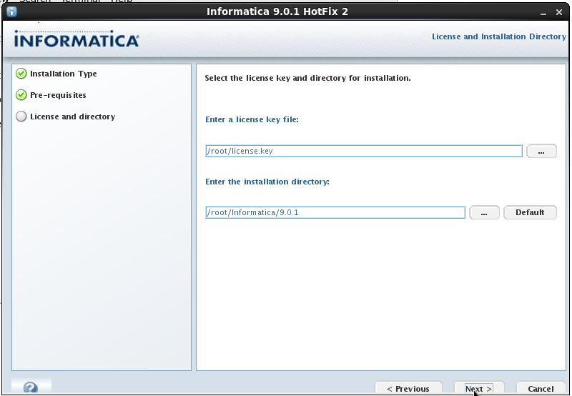

Step-4:

Verify the Installation Pre-requisites (if any not meet our requirements, it will stop our Installation) then click “Next”.

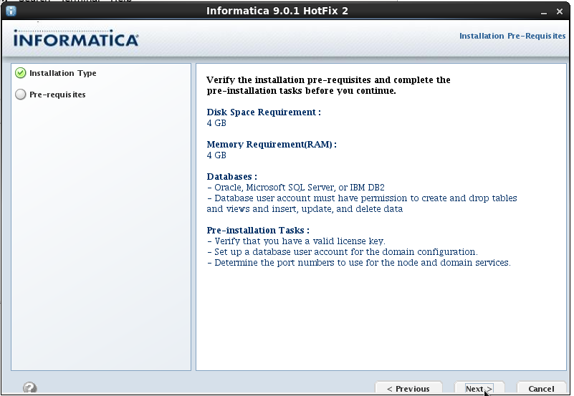

Step-5:

If everything is fine then our Installation will start.

Step-6:

Select Database and Enter Database Informatica Domain UserID& Password

Ex:Database :Oracle
Database UserID: infa_domain
User Password : Password Provided by ETL Team

And Enter Database Server Name, Port Number and Connecting String(TNS name).

Database Address :XXX.XXX.X.XX:1521
Database Service Name: orcl

If information is correct then Click “Test Connection”

If Status like “The connection is failed” means provided wrong Information.
(Or)
If Status Like “The connection is successful” then Click “Next”

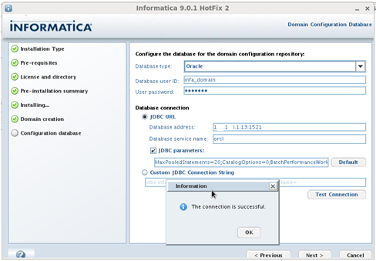

Step-7:

Enter Administrator Domain Password
Ex: Domain Password: Password Provided by ETL Team
Confirm Password: Password Provided by ETL Team

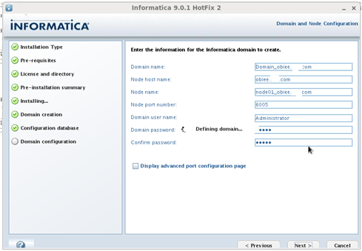

Step-8:

Informatica server Installation done.
So click”Done”.

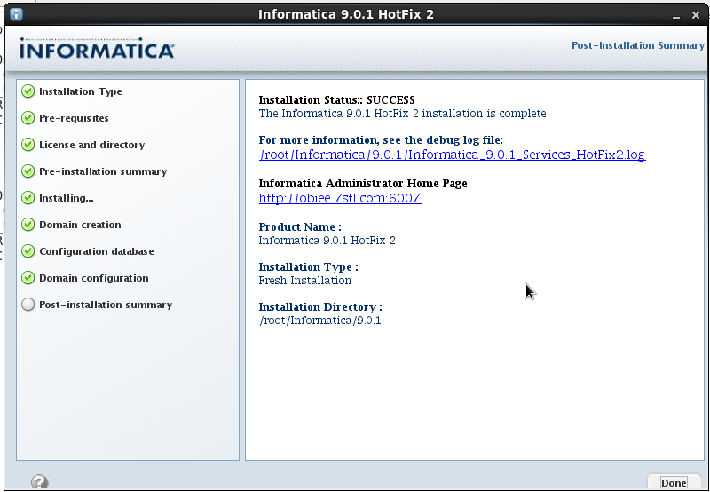

Testing on Informatica Installation

Step-1:
Open any browser, enter Domain name & Port number.
Ex: https://obiee.anil:8443/administrator

Step-2:
Enter Informatica Administrator username & Password (Case Sensitive)
Ex: Administrator username: Administrator
Administrator password: Password Provided by ETL Team

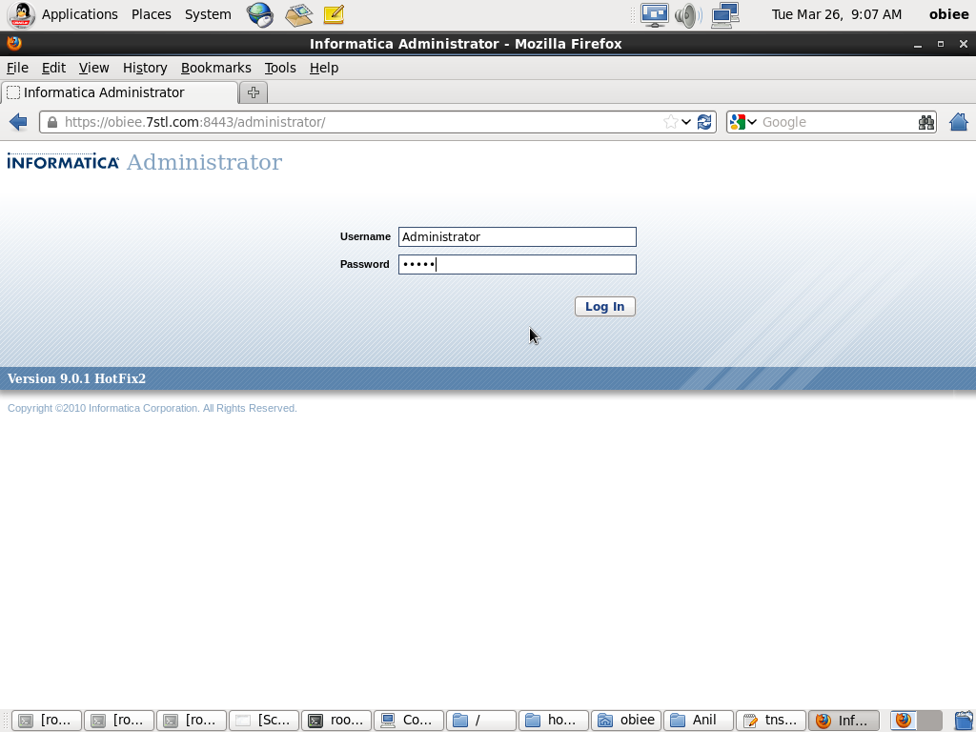

Step-3:
This is Administrator Page

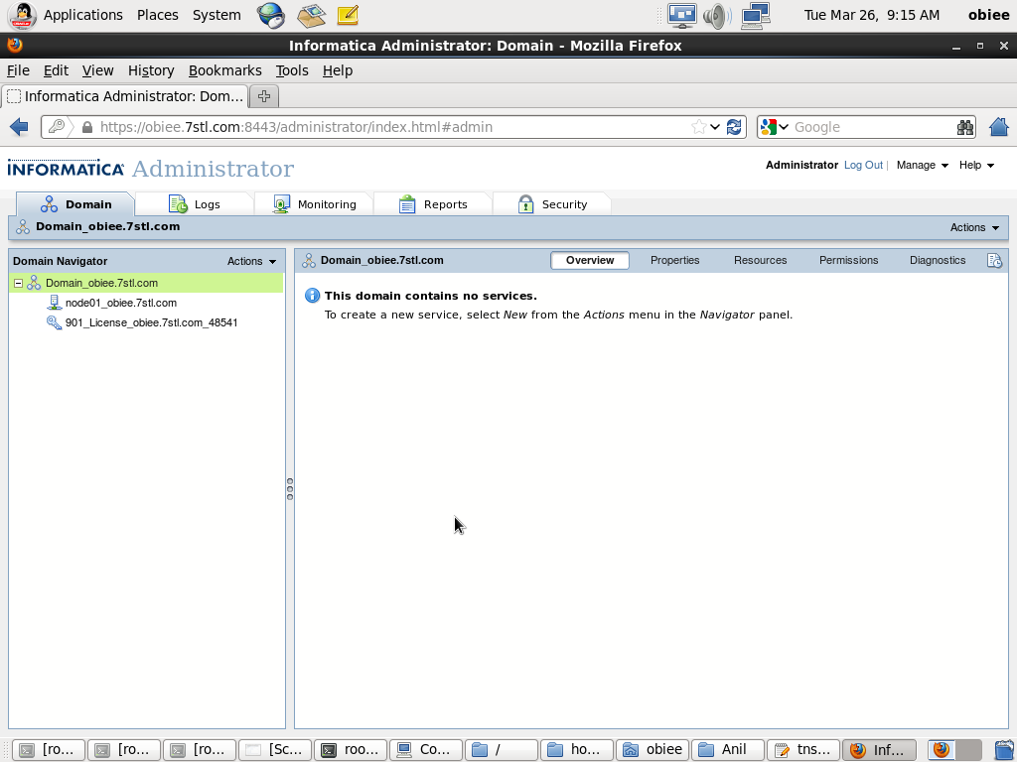

Informatica Server 9.0.1 installed successfully

